Research introduction:

The Effects of Pollution in the Ocean
By:Eliana Bentley
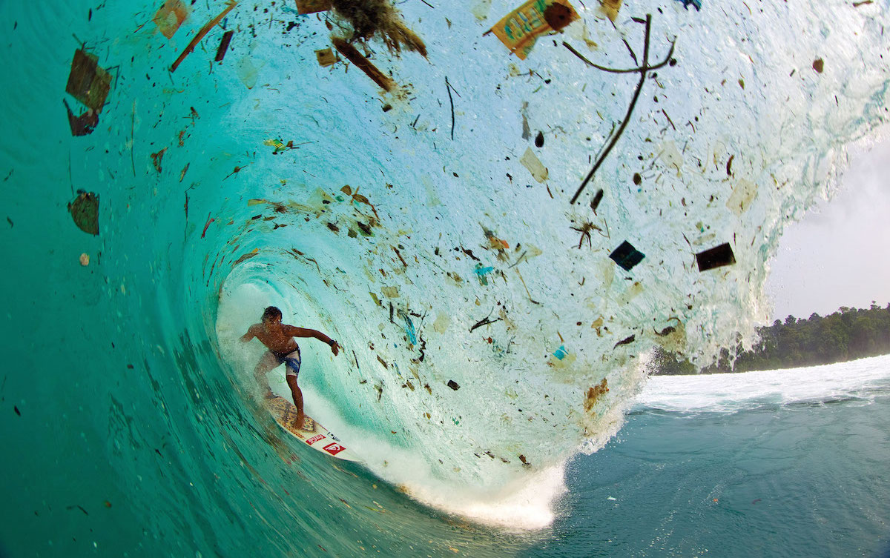
Photo from www.Monterey Bay Aquarium Shorelines

Pollution is unnatural elements that are exposed to the environment. Pollution has been increasing since the industrial revolution of natural resources were depleted and the use of factories increasing fossil fuels increased. In the 1970s The Clean Air Act was signed and the Clean Water Act were signed. This gave the EPA the authority to implement pollution control programs such as setting wastewater standards for industry.” (sourced by the EPA 2017).
There is presently a significant amount of runoff plotting the ocean. Runoff from land based sores is polluting the ocean. This because of the surplus of human activities such as agriculture, oil and sewers. Ocean pollution affects marine life and humans. Location is a factor in water quality because of the runoff. For example urban runoff affects water quality the most because it ” carries pollutants such as oil, dirt, chemicals, and lawn fertilizers directly to streams and rivers” (EPA 2003)
Our objective of are study is to find out what the current water quality in San Diego Our hypothesis is we will find the the more pollution there is there will be a lower water quality and vise versa.

Sources:
- https://www.montereybayaquarium.org/members/shorelines/shorelines-spring-2017/ocean-plastic-pollution

- https://oceanservice.noaa.gov/facts/pollution.html
- http://www.history.com/topics/water-and-air-pollution
- http://study.com/academy/lesson/the-industrial-revolution-impacts-on-the-environment.html
https://www.epa.gov/laws-regulations/history-clean-water-act
- http://www.planetaid.org/blog/how-ocean-pollution-affects-humans
- https://www3.epa.gov/npdes/pubs/nps_urban-facts_final.pdf

